Module: 1

SE – Overview of IT Industry

**1.What is software? What is software engineering?**

* Software refers to a set of instructions, data, or programs used to operate computers and execute specific tasks. It is the non-tangible component of computers, as opposed to hardware, which is the physical aspect.
* Software engineering is the systematic application of engineering principles to the development, maintenance, and management of software. It involves the use of methodologies, tools, and techniques to design, develop, test, and maintain software systems, ensuring they are reliable, efficient, and meet user requirements.

**2. Explain types of software**

* There are 5 types of software:-

### 1) Application Software

Application software is designed to help users perform specific tasks or activities.

* **Productivity Software**: Programs for creating documents, presentations, spreadsheets, and other office-related tasks (e.g., Microsoft Office, Google Docs).

2) System software

System software serves as a platform for other software and manages the hardware of a computer system.

* **Operating Systems (OS)**: The primary software that manages all other programs and hardware on a computer (e.g., Windows, macOS, Linux).

3) Driver software

A driver, or device driver, is a set of files that tells a piece of hardware how to function by communicating with a computer's operating system. All pieces of hardware require a driver, from internal computer components, such as your graphics card, to external peripherals, like a printer.

**3. What is SDLC? Explain each phase of SDLC**

* The Software Development Life Cycle (SDLC) is a structured process used for developing software applications. It consists of a series of phases that provide a framework for planning, creating, testing, and deploying information systems. The goal of SDLC is to produce high-quality software that meets or exceeds customer expectations, reaches completion within times and cost estimates, and works efficiently and effectively in the current and planned IT infrastructure.

**Phases of SDLC**

1. **Planning**:
   * Define the scope and purpose of the project.
   * Conduct feasibility studies.
   * Create project plans, schedules, and resource allocation.
2. **Requirements Analysis**:
   * Gather and document user requirements.
   * Develop functional and non-functional requirements.
   * Create use case diagrams and requirements specifications.
3. **Design**:
   * Create architectural designs and system models.
   * Define system components, interfaces, and data flow.
   * Develop detailed designs for each system component.
4. **Implementation (Coding)**:
   * Translate design specifications into source code.
   * Develop the software using appropriate programming languages and tools.
   * Perform unit testing and code reviews.
5. **Testing**:
   * Perform various tests (e.g., integration, system, acceptance) to ensure software quality.
   * Identify and fix defects or bugs.
   * Validate that the software meets all requirements and works as expected.
6. **Deployment**:
   * Release the software to the production environment.
   * Conduct user training and support.
   * Ensure the software is correctly installed and configured.
7. **Maintenance**:
   * Monitor software performance and fix any issues that arise.
   * Update software to adapt to changes in user requirements or technology.
   * Perform regular maintenance tasks, such as patching and upgrading.

**Models of SDLC**

1. **Waterfall Model**: A linear and sequential approach where each phase must be completed before the next begins.
2. **Agile Model**: An iterative and incremental approach that emphasizes flexibility and customer collaboration.
3. **Iterative Model**: Develops the system through repeated cycles (iterations), allowing for refinement through each iteration.
4. **V-Model (Validation and Verification)**: An extension of the Waterfall Model that emphasizes validation and verification at each stage.
5. **Spiral Model**: Combines iterative development with risk assessment, allowing for multiple cycles of refinement and risk evaluation.

4. What is DFD? Create a DFD diagram on Flipkart

* A Data Flow Diagram (DFD) is a graphical representation of the flow of data through a system. It shows how data is processed and transferred between different entities, processes, and data stores. DFDs are used to visualize the major steps and data involved in a system and are useful for both analysis and design of information systems.
* Diagram of flipkart:-

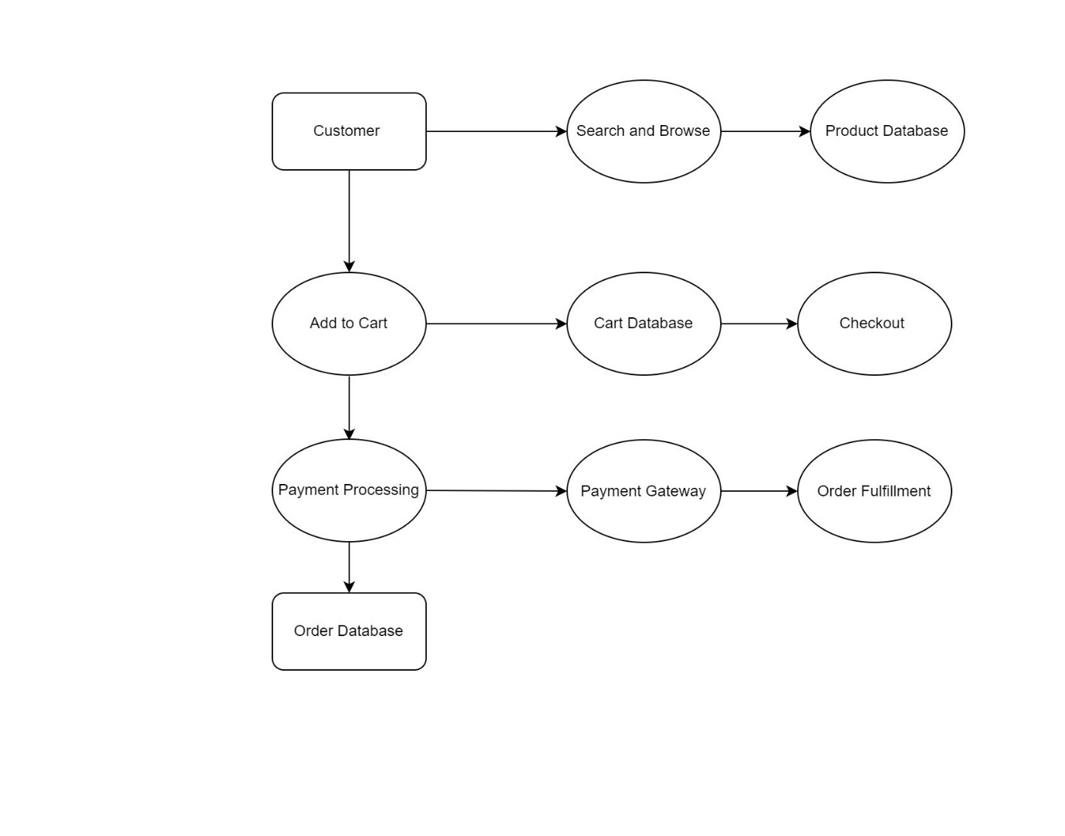

1. What is Flow chart? Create a flowchart to make addition of two numbers
   * A flowchart is a graphical representation of a process or algorithm, using symbols such as ovals, rectangles, diamonds, and arrows to depict different steps and the flow of control. It helps in visualizing and understanding the sequence of operations or decisions within a process.
   * Flowchart to make addition of two numbers:-

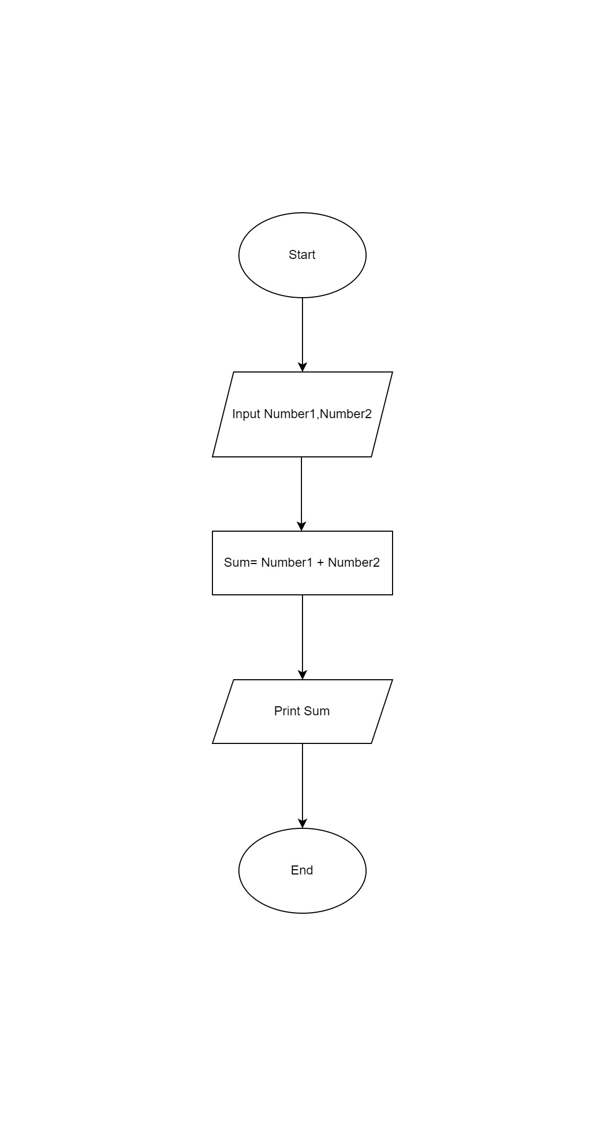

6. What is Use case Diagram? Create a use-case on bill payment on paytm.

* A use case diagram is a type of behavioral diagram defined by the Unified Modeling Language (UML) that represents the interactions between users (actors) and a system. It depicts the various use cases (functions or features) that a system provides and the actors that interact with those use cases. Use case diagrams are used to capture the functional requirements of a system and to visualize the relationship between the system and its external entities.
* Paytm use-case diagram:

